Step 1 :login to the amazon console and go on the amazon sagemaker.

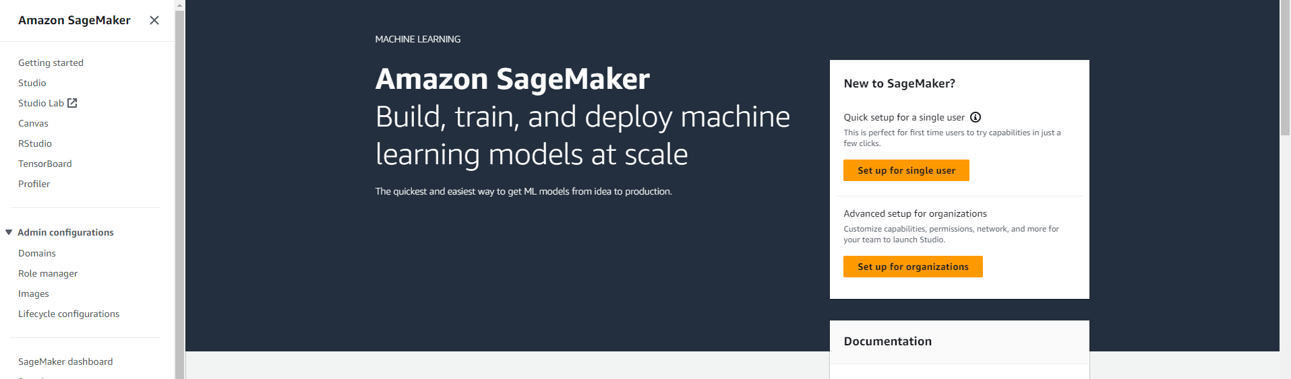

Step 2 : Then select domain and create a new domain and click on the set up.

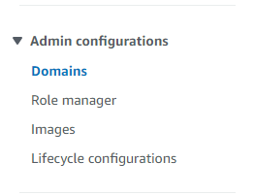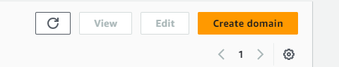

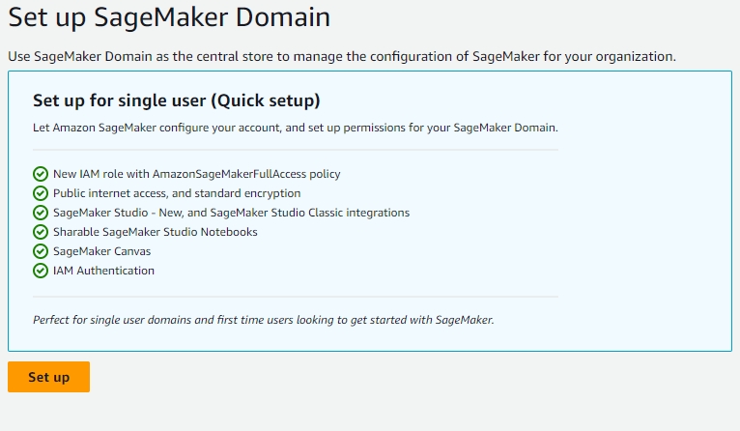

Step 3 : click on the notebook and create a new notebook instance.

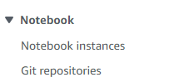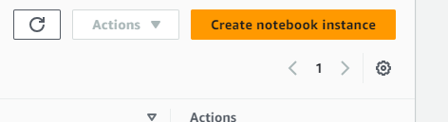

Notebook is successfully created. 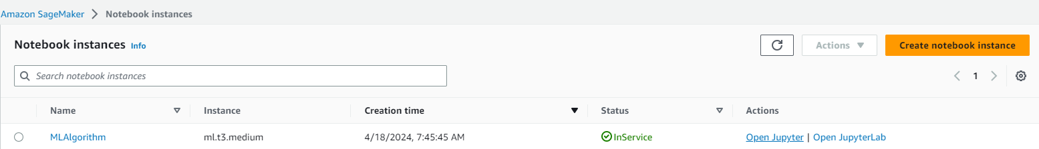

Step 4 : after succesfully creating a notebook instance open the python and train the model.

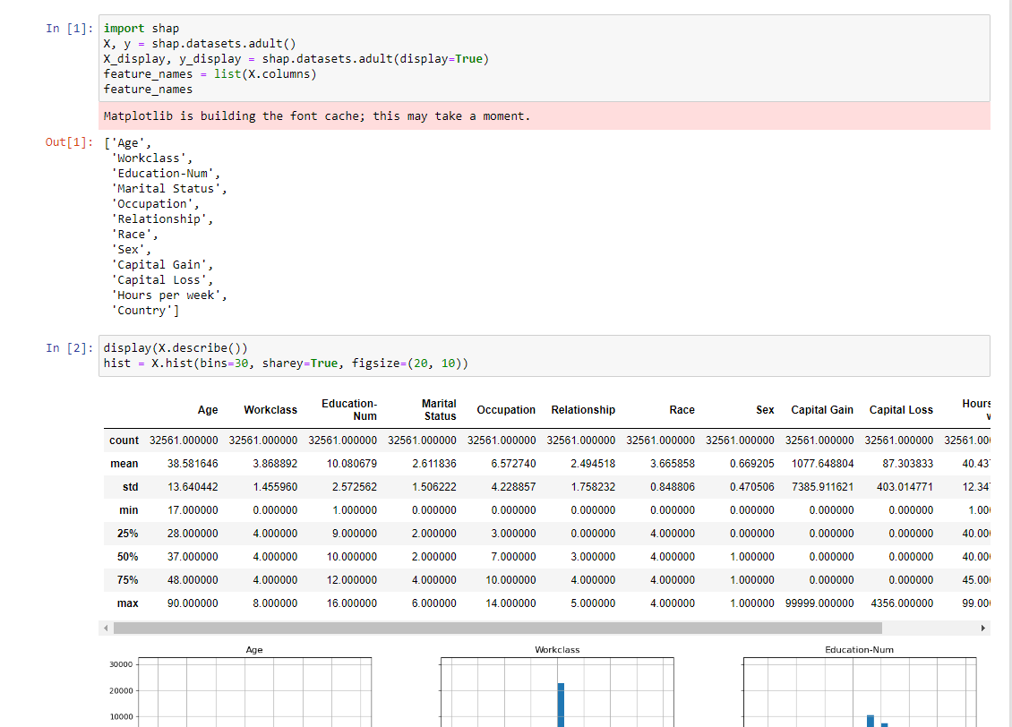

Step 5 : Deploy the model on amazon ec2.

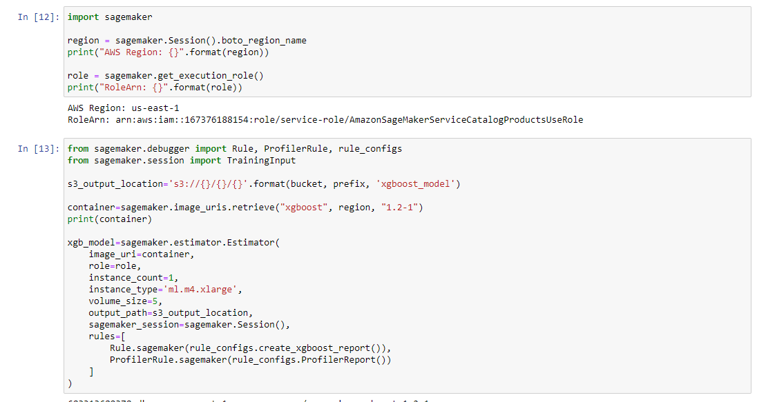

Step 6 : after the model is successfully deployed.

